Thank you for your participation in this study. Briefly, we will take the sample you provide, and extract the DNA from the bacteria living on the surface of your shoe sole and cell phone. We will then sequence a gene, which is common to all known bacteria, called 16S rRNA, from all the bacteria in these samples. We anticipate that there could be as many as 10 billion bacterial cells living on your phone and shoe sole, and we will attempt to characterize these microbial communities. We would also like to see how these communities vary between different people and different shoes or phones. Therefore, we would greatly appreciate it if you could fill in this brief questionnaire:

Name: __________________________________________ DOB: _________________
Email: __________________________________________ Tube ID: _____________
City and State of Residence: ______________________________________________

Shoe details:
Make and type of shoe (e.g. Nike, trainer): ______________________
Model of shoe (if known, e.g. Nike Air): ________________________
Approximate age of shoe (e.g. 1 month, 1 year, 5 years?): ____________
Shoe sole material (e.g. leather, rubber, etc.): _____________________

Phone details:
Make and Model of phone (e.g. Apple, iPhone 4): _________________
Approximate age of phone: ___________________________________

Kit Contents:
A zip-loc bag containing a pair of non-latex surgical gloves, wire cutters, an alcohol prep pad, two Q-tips, and two tubes with sampling solution.

Instructions:
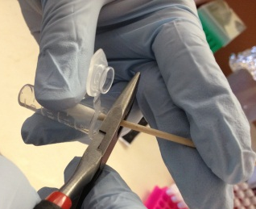
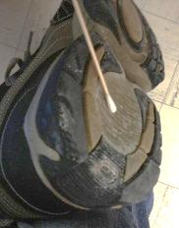
- Please fill out this survey as best you can.
- Please then place the gloves on.
- Unsheathe the wire cutter by pulling the handles apart, and sterilize it with the alcohol prep pad (reuse in step 5).
- For each of the two sampling locations:
  - Take a sterile Q-tip and wet the end with all of the solution in the tube marked “Cellphone” or “Shoe”.
  - Swab the corresponding site with the Q-tip for 10 seconds.
  - Use the wire cutters to cut off the cotton tip into the same tube.
- After sampling, clean the sampled area on your cellphone with the alcohol prep pad.
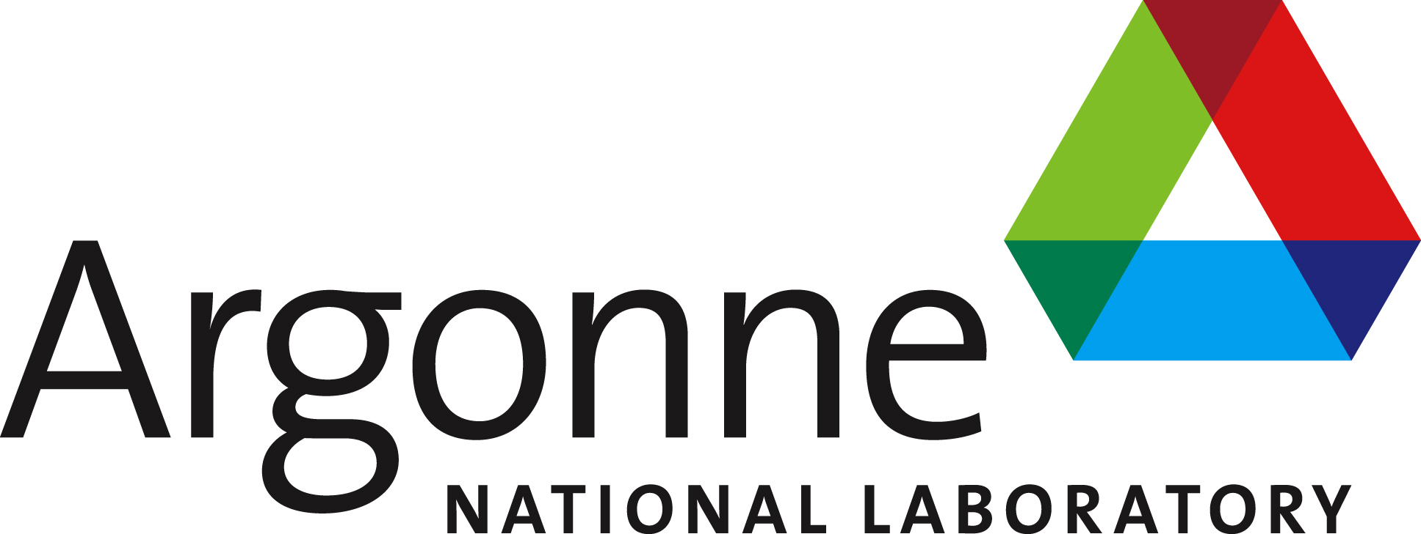
- Return all materials to the zip-loc bag and place it in the dry ice container.

